Check for Balanced Brackets in an expression

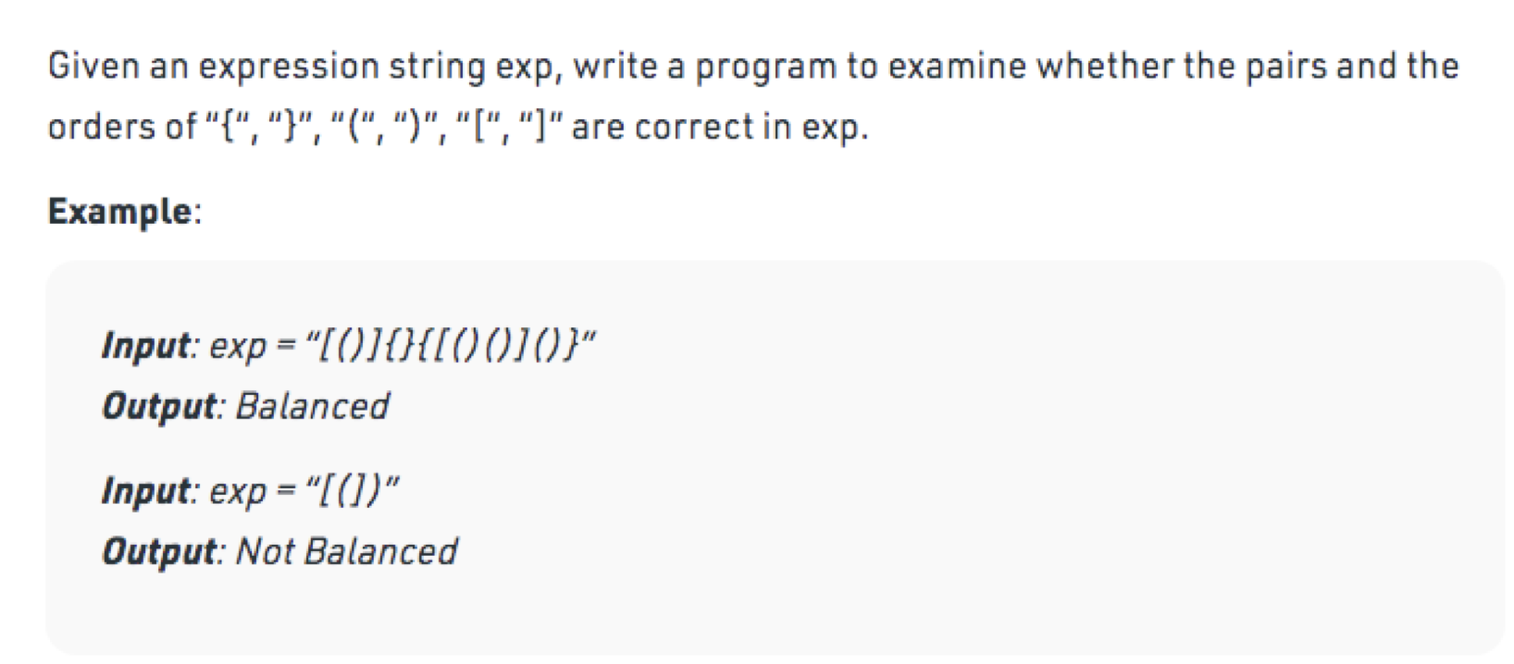

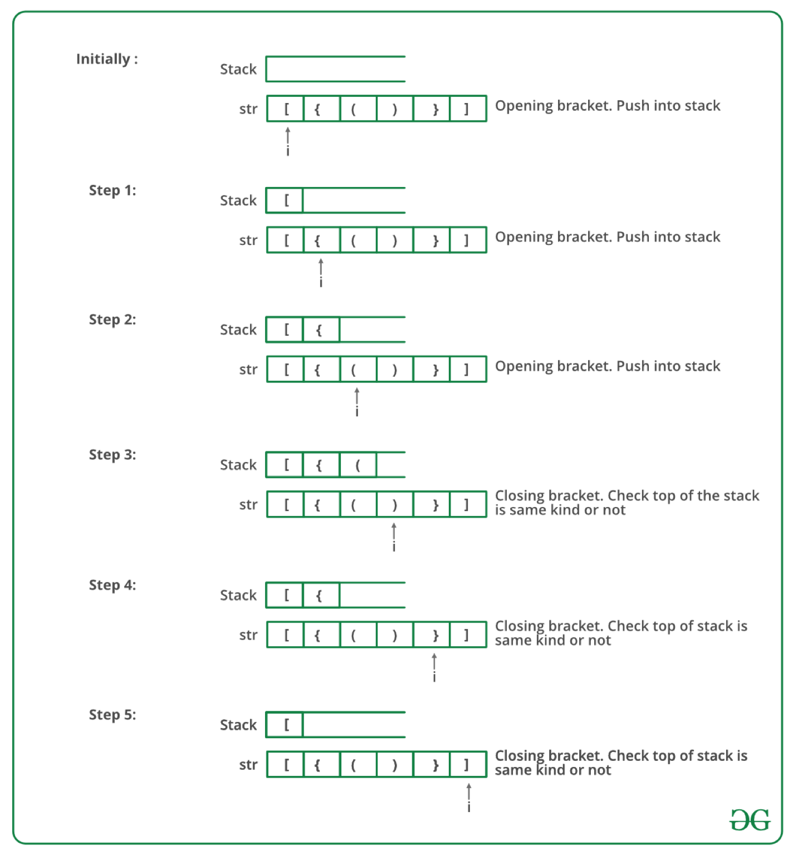

Solution
https://replit.com/@rohitbhardwaj/Stack-problems#BalancedBrackets.java

